NAAN MUDHALVAN PROJECT

LAPTOP REQUEST CATALOG ITEM

Team Id: **EAF32E36B5FBA90879D4FEDE**

Team Members: 4

**Team Leader**: **Kavitha.S**

Team members:

1.Sweatha.S

2.Divya.P

3.Harini.R

**Problem Statement**:

To create a service catalog item so that users can quickly and easily request a laptop to the organization for completeing the task.

**MILESTONE 1:** **UPDATE SET**

ACTIVITY 1: **Create local update sets**

1.Search for service now and open it.

2.Select all and then search for update set

3. Under system update set select local update set

4.Now click news

5.Then fill the details and give update set as “Laptop Request”

6.Finally click submit.

**MILESTONE2: Catalog Item**

Activity1: **Create Service Catalog Item**

1.Go to Servicenow

2.Select all and type service catalog

3.Under catalog definitions select maintain items

4.Click new

5.Now fill the details so that a new catalog item is created

**Name** : Laptop Request

**Catalog** : Service Catalog

**Category** : Hardware

**Short description** :Use this item to request a

new laptop

Finally click on save

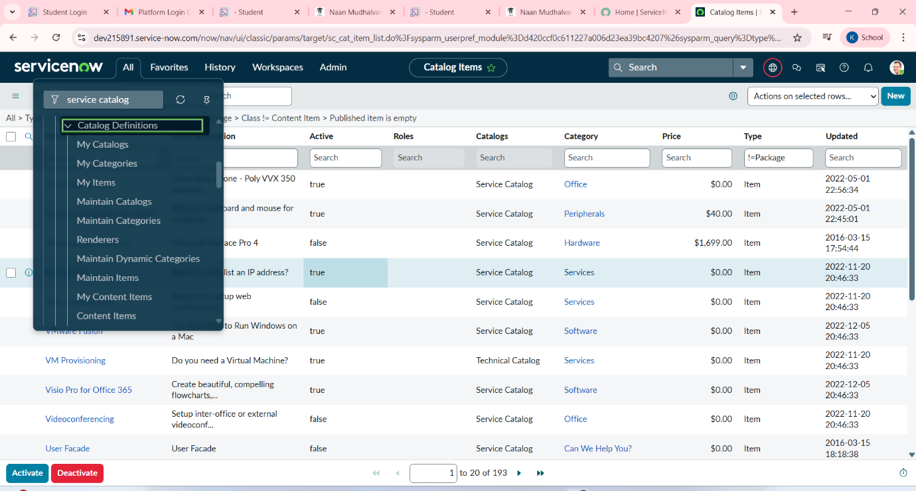

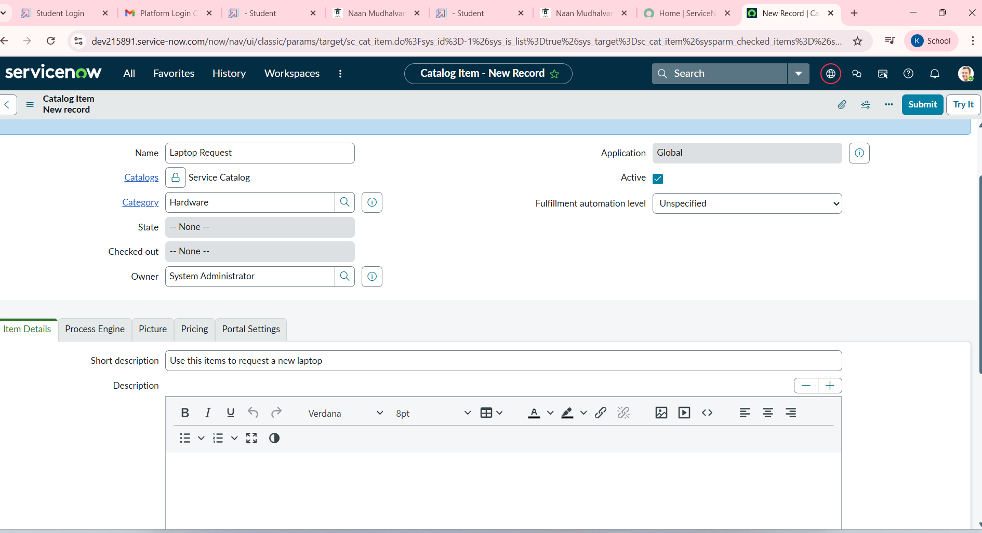

**Activity 2**: Add Variables

1:# After saving scroll down and click on the variable

# click on new and enter the details

1**.variable**  : Laptop model

**Type** : single line text

**Name** : laptop_ model

**order :** 100

# click submit

# click new and add the remaining variables in the above process

2.**variable** : Justification

**Type** : multi line text

**Name** : justification

**Order** : 200

3. variable : Additional Accessories

Type : check box

Name : additional _ accessories

Order : 300

4.**variable** : Accessories Details

**Type** : multi line text

**Name** : accessories_details

**Order** : 400

# After adding these variables we should save the catalog item form

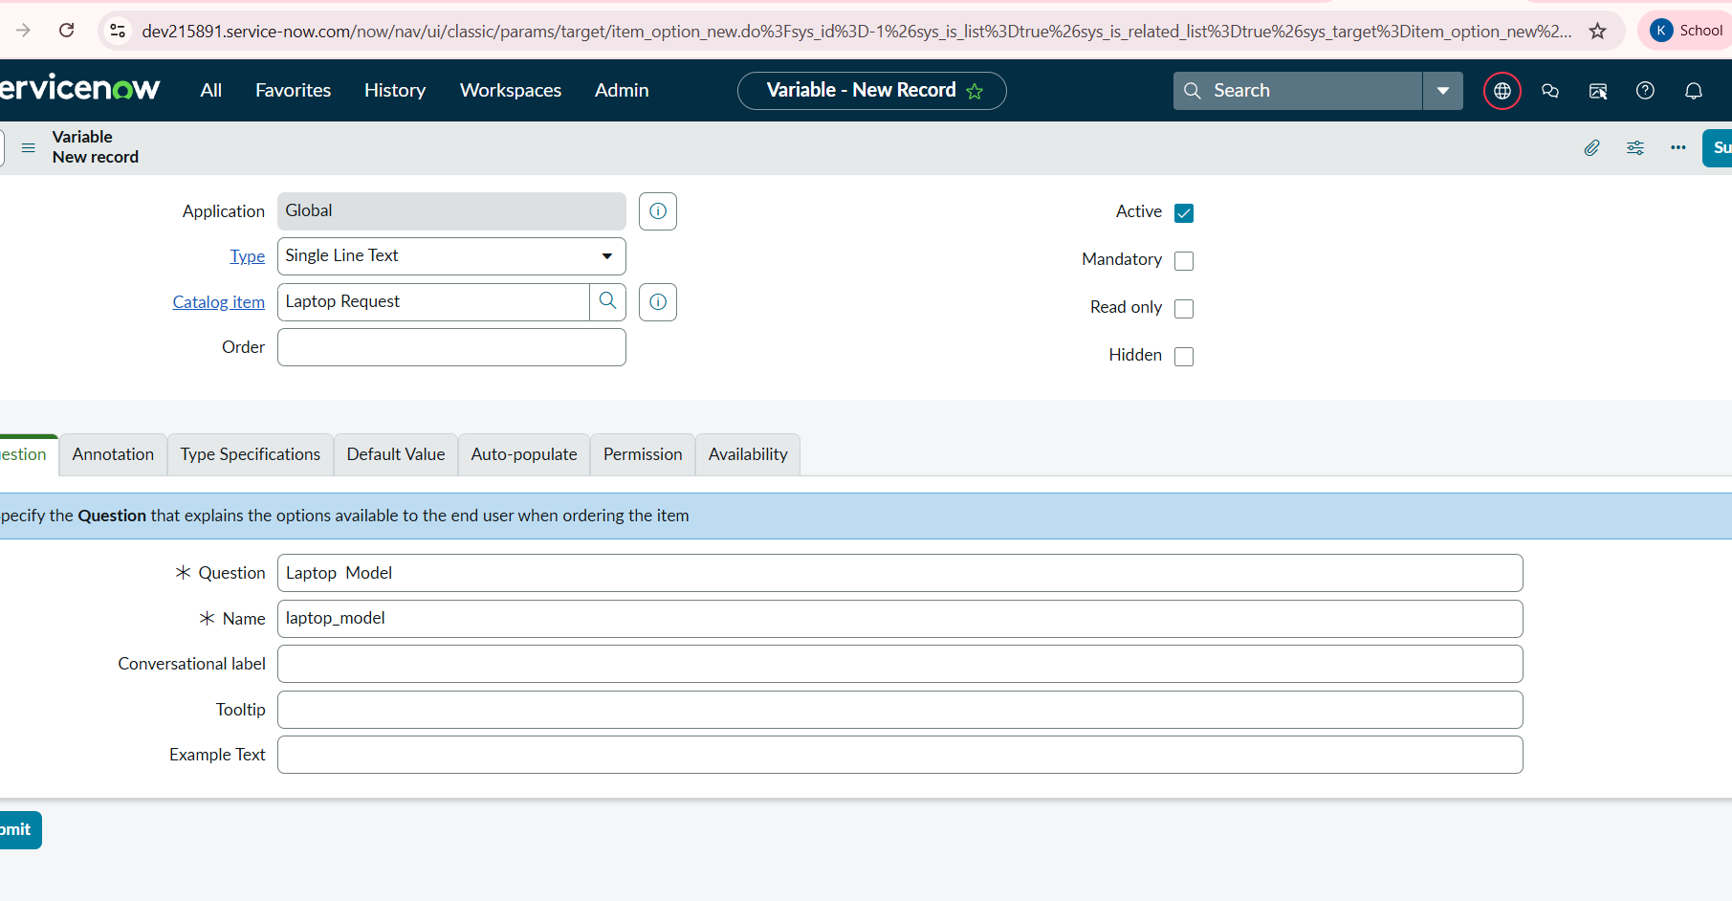

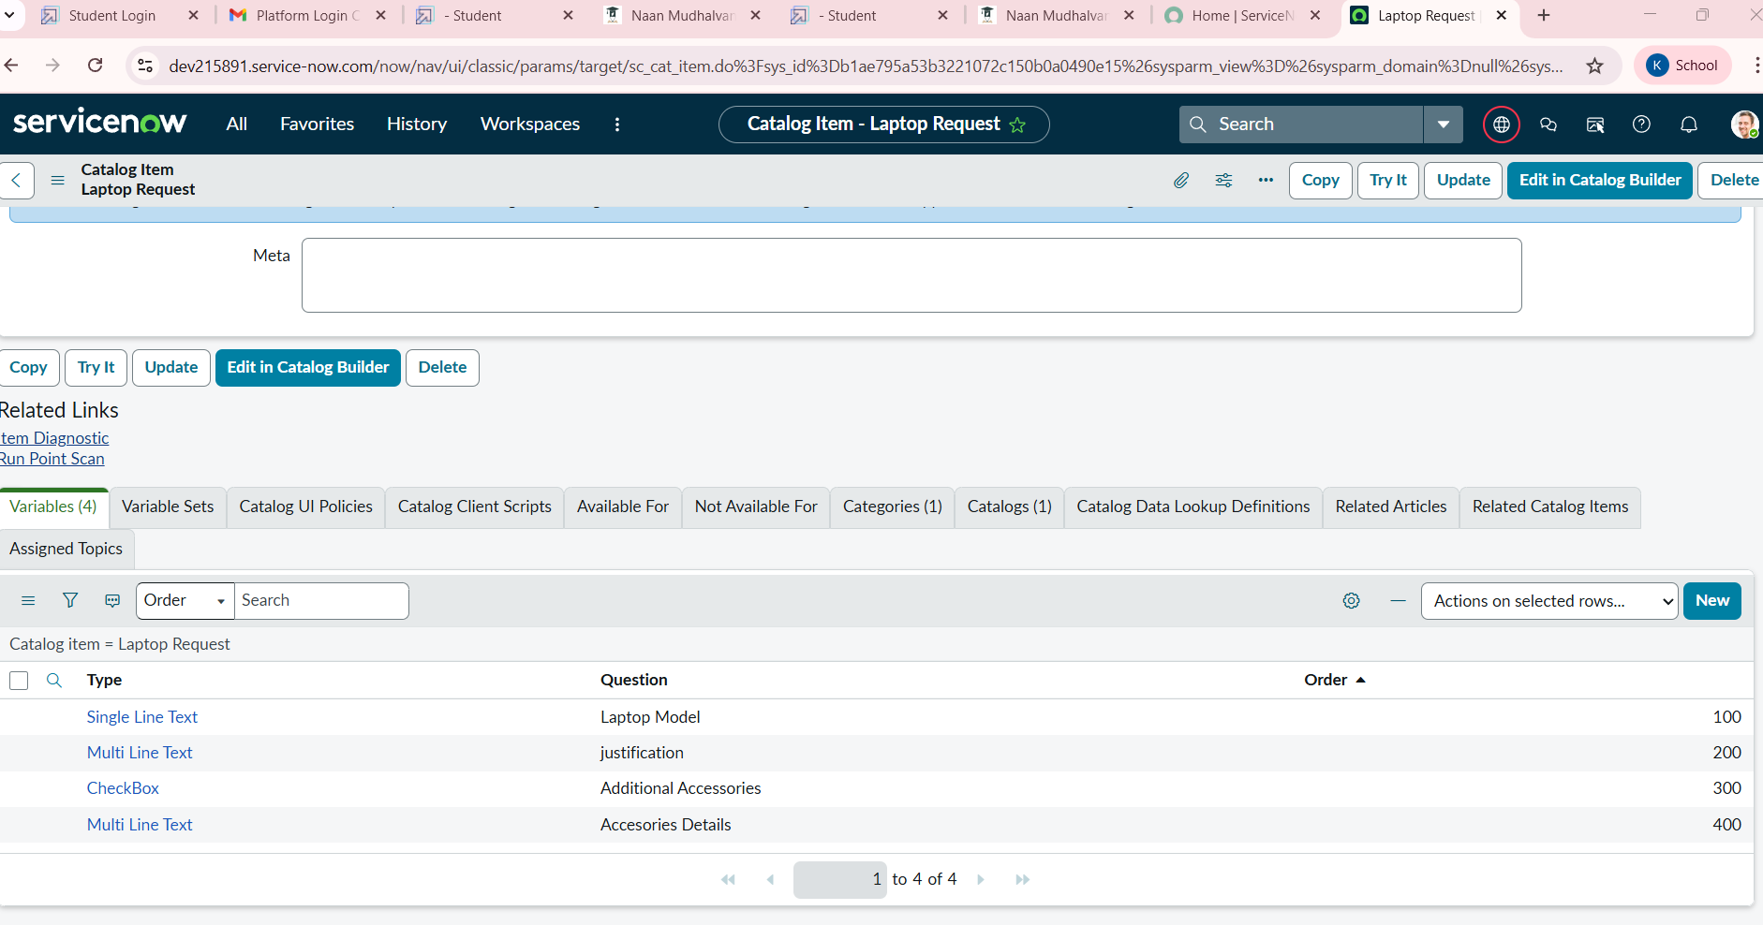

**MILESTONE 3** : **UI POLICY**

**Activity :** Create catalog ui policies

**#** click all

**#** search service catalog

**#** under the catalog definition select maintain

item

**#** select laptop request and scroll down to click on

catalog ui policies

**#** In the catalog ui policies tab click new

**#** Provide short description as show accessories

details

**#** set the catalog condition in the related list tab**.**

**Field :** additional_accessories

**Operator :** is

**Value :** true

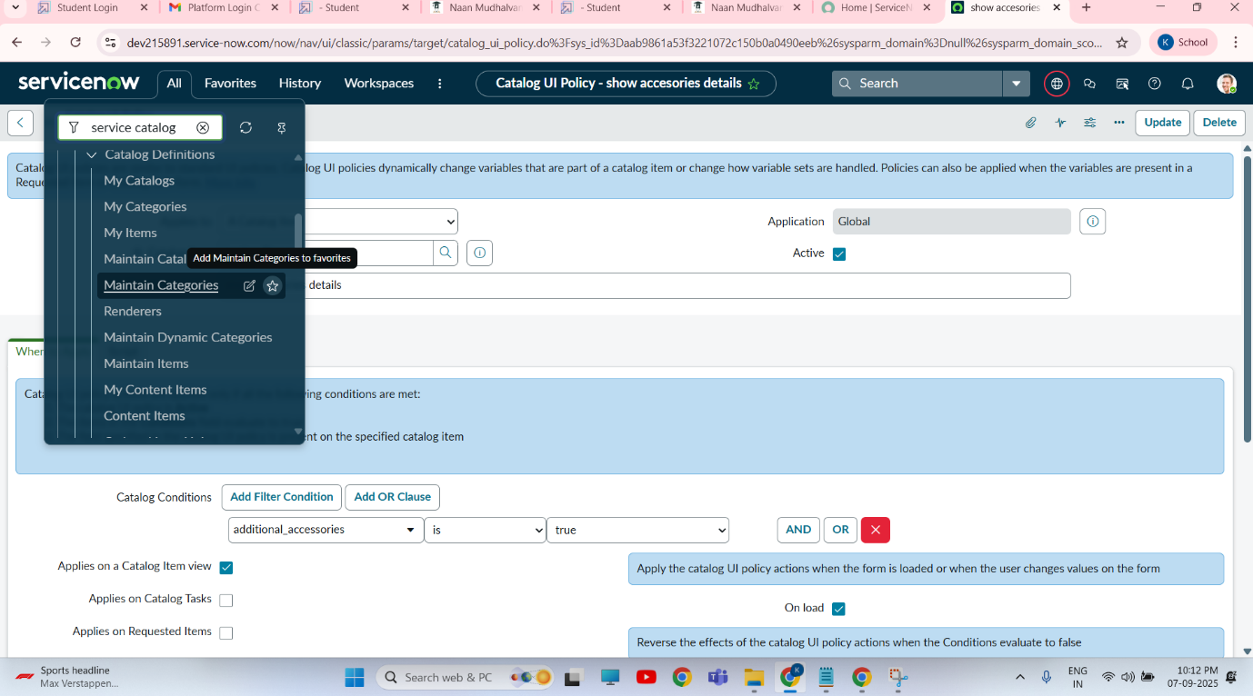

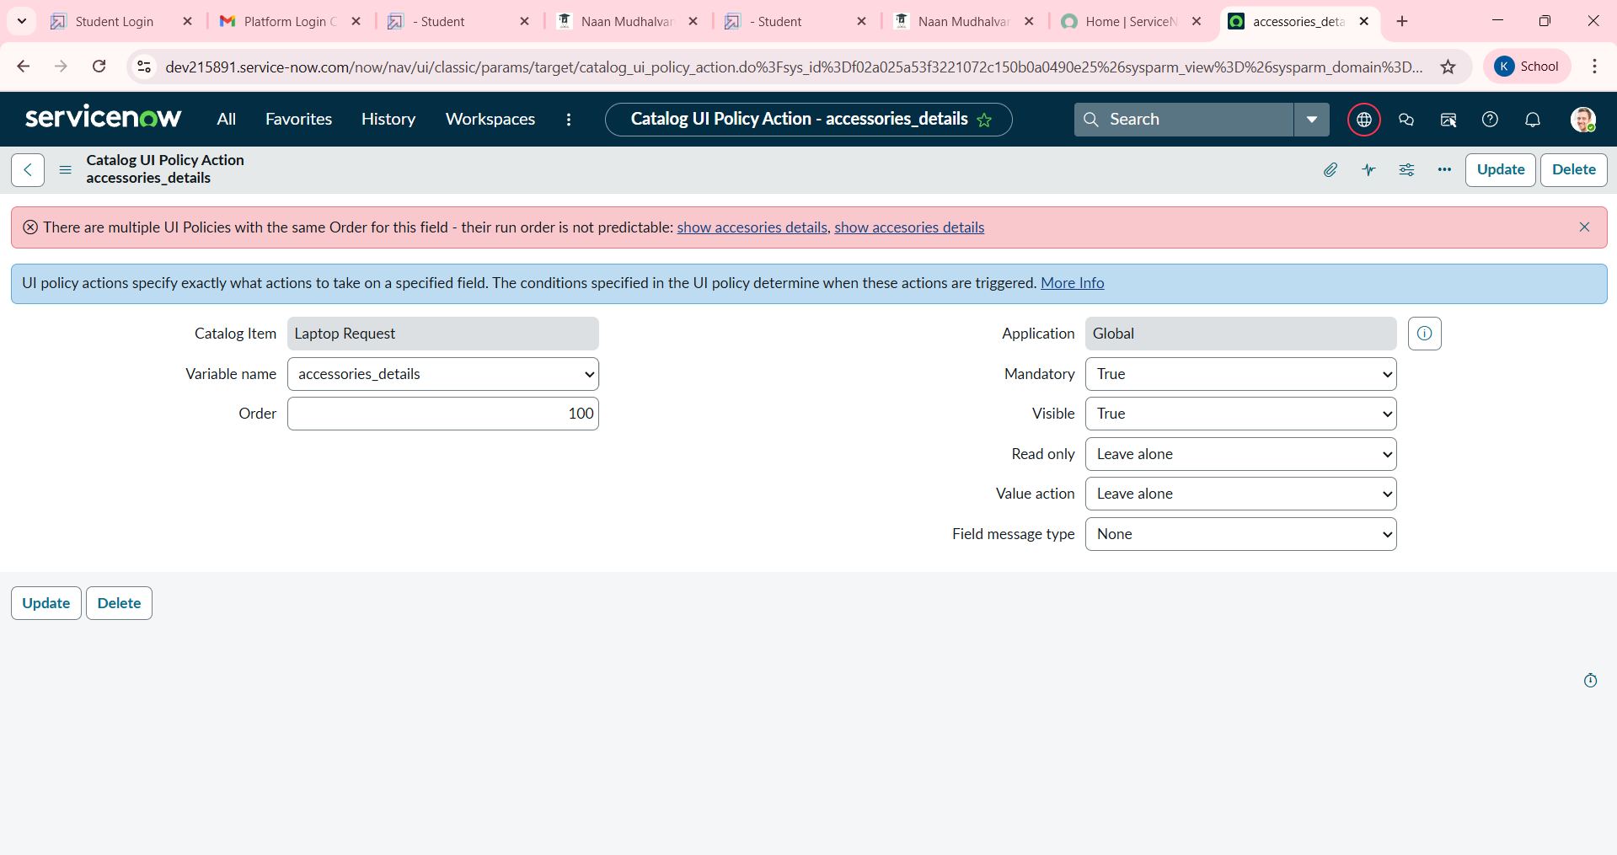

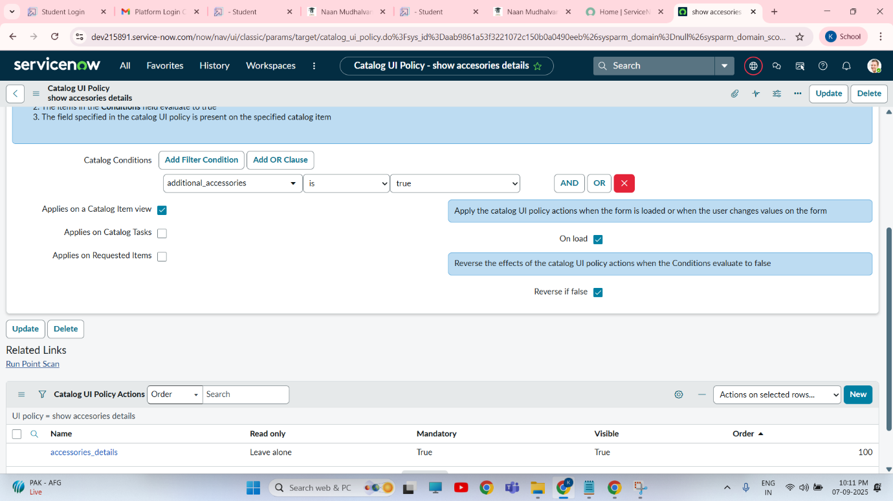

**MILESTONE 4** : **UI Action**

**ACTIVITY**  : create ui action

# open service now

# click All then search for ui action

# under the system definition select ui action

# click new

# to create ui action fill the following details

**Table** : shopping cart ( sc_cart)

**Order** : 100

**Action name** : Reset form

**Client** : checked

**Script** : function reset form(){g_form.clear form();//clears all filds in the form alert(“The form has been reset.”);}

Click on save

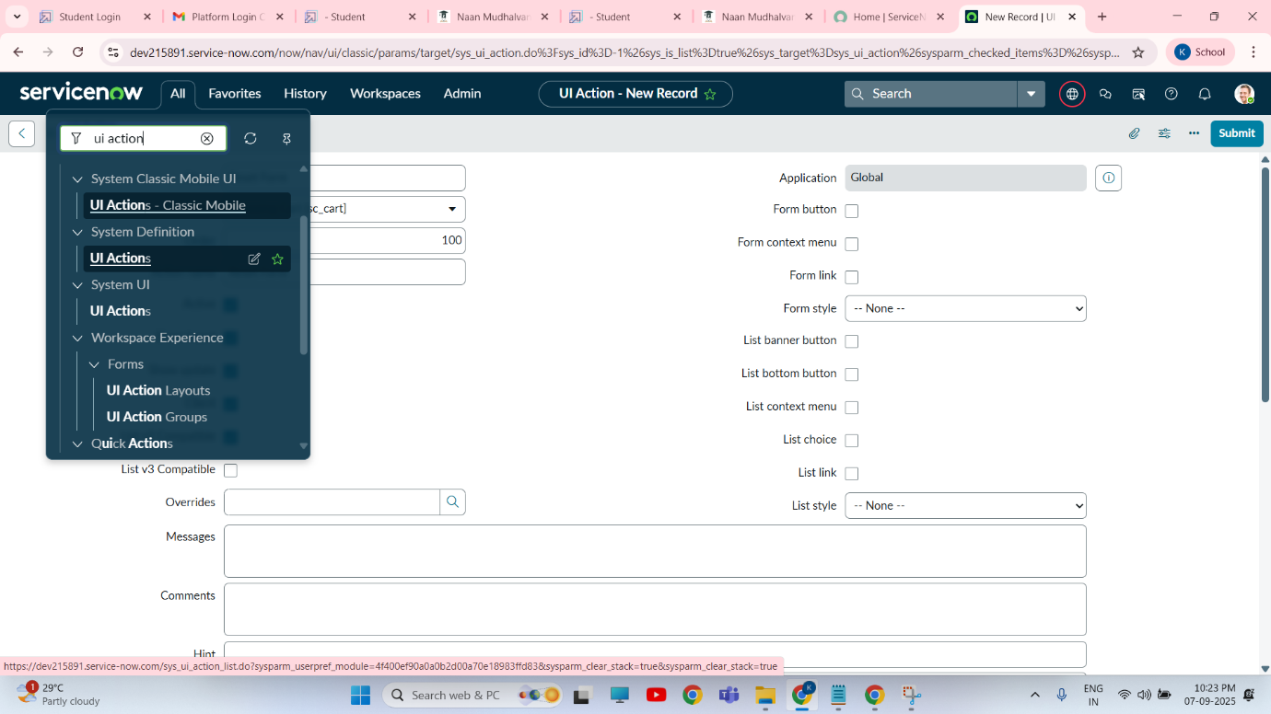

**MILESTONE 5**  : **EXPORT UPDATE SET**

**ACTIVITY** : Exporting changes to another

Instances

**#** click all and then search for the update sets

**#** then select the local update set

**#** then select the created update set ‘ laptop request project ‘

**#** then set the state to ‘complete’

**#** in the related list update tab ,updates are visible which we perform under this update set.

**#** click export to XML ,it will download one file

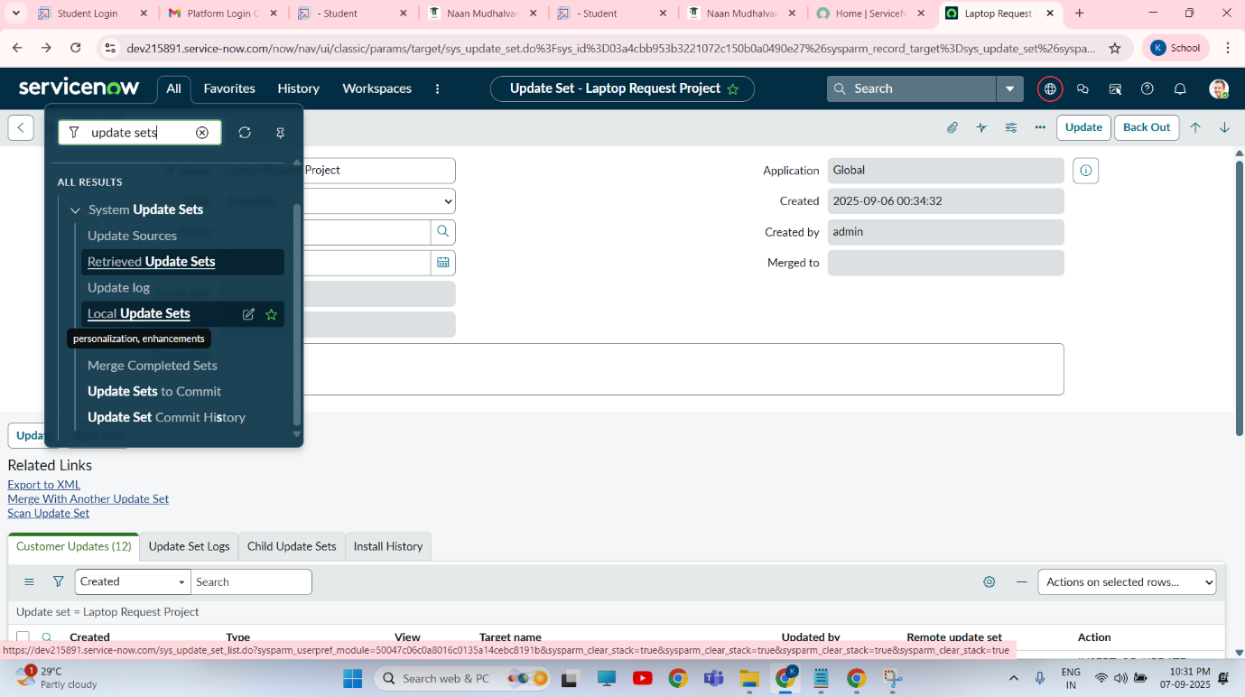

**MILESTONE 6** **: LOGIN TO ANOTHER INSTANCE**

**ACTIVITY** : Retriving the update sets

**\***  now open another instance in incognition window

**\***  then login with credentials

**\***  click all and then search for the update sets

**\*** under the system update set you should select the “Retrieved update set”

**\*** Retrieved update set will be opened and then scroll down

**\***  after that you should click import update set from XML

**\***  then upload the downloaded file in XML file

**\*** then click on upload and it will be uploaded

**\*** you should open the Retrieved update set ‘ laptop request project’

**\*** then click on to preview update set

* then click to commit update set

* you should also see the related tab updates

* click update set in the instance by doing these we will get the updates that are done in the previous instance

**MILESTONE 7** : **TESTING**

**ACTIVITY :** Test catalog item

**#** you should search for the service catalog in application navigator in target instance

**#** under the service catalog you should select catalog

**#** and then select hardware category and search for ‘laptop request’ item

**#** now select the laptop request item and open it

**#** it will show three variables

**#** when we click to additional accessories checkbox then it will show accessories details field

**#** results can be seen

**Conclusion : This project successfully implemented a user friendly catalog item for requesting laptops within the organization/**

**By this request we have achieved and efficient method for obtaining the necessary computing resources.**

**\*\*\*\*\*\*\*\*\*\*\*\*\*\*\*\*\*\*\*\*\*\*\*\*\***